|  |  |
| --- | --- |
| **AER 1216H – FUNDAMENTALS OF UAS PROJECT** | |
| PARTICIPANTS | PRAKRITI SAINI (1007495195) |
| RUTVIK SOLANKI (1008247531) |
| SIVA SUBRAMANIAN VADAKKANTHARA SIVARAMAKRISHNAN (1006892757) |
| COURSE INSTRUCTOR | Prof. HUGH LIU |

|  |  |  |  |
| --- | --- | --- | --- |
| **TABLE OF CONTENTS** | | | |
| **S.NO** | | **CONTENT** | **PAGE NO** |
| 1 |  | OVERVIEW |  |
| 2 |  | TASKS |  |
| 3 |  | FIXED WING DEVELOPMENT |  |
|  | 3.1 | CALCULATION OF RANGE AND ENDURANCE |  |
|  | 3.2 | DYNAMICS MODEL |  |
|  | 3.3 | ALTITUDE HOLD CONTROL |  |
|  | 3.4 | SIMULATION AND MANEUVERS |  |
| 4 |  | MULTI-ROTOR UAS DEVELOPMENT |  |
|  | 4.1 | CALCULATION OF RANGE AND ENDURANCE |  |
|  | 4.2 | DYNAMICS MODEL |  |
|  | 4.3 | POSITION/ORIENTATION CONTROL |  |
|  | 4.4 | SIMULATION AND MANEUVERS |  |
| 5 |  | CONCLUSION |  |
| 6 |  | REFERENCES |  |

|  |  |
| --- | --- |
| **LIST OF FIGURES** | |
|  |  |
|  |  |
|  |  |
|  |  |
|  |  |
|  |  |

|  |  |
| --- | --- |
| **LIST OF TABLES** | |
|  |  |
|  |  |
|  |  |
|  |  |
|  |  |
|  |  |

**OVERVIEW:**

An unmanned aerial vehicle (UAV), commonly known as a drone, is an aircraft without any human pilot, crew, or passengers on board. UAVs are a component of an unmanned aircraft system (UAS), which has three basic components:

1. An autonomous or human-operated control system which is usually on the ground or a ship but may be on another airborne platform.
2. An Unmanned Aerial Vehicle (UAV)
3. A command and control (C2) system - sometimes referred to as a communication, command, and control (C3) system - to link the two.

These systems include but are not limited to remotely piloted air systems (RPAS) in which the UAV is controlled by a 'pilot' using a radio data link from a remote location. UAS can also include an autonomously controlled UAV or, more likely, a semi-autonomous UAV.

NOTE: In recent years, the tendency to refer to any UAV as a "drone" has developed but the term is not universally considered appropriate. UAVs can vary in size from those which can be hand launched to purpose-built or adapted vehicles the size of conventional fixed or rotary wing aircraft.

In this given task, we have designed and developed two individual UAS systems (Fixed-Wing sUAS and multi-rotor drone) with respect to the given configuration. The design and analysis of the UAS system are done with respect to the selection of parameters that suit the given configuration. A linearized dynamics model was developed and subjected to multiple simulations and test conditions in order to estimate the stability of the system. The control system is implemented by incorporating PID control over the control points of the aircraft and the test results are established. The software platform used for the analysis of the aircraft system is MATLAB and Simulink.

The selection of components for the Fixed-Wing and the Multi-Rotor UAS are given in the following tables:

1. **FIXED-WING:**

|  |  |  |
| --- | --- | --- |
| **COMPONENT/PARAMETER** | **AVAILABLE CONFIGURATIONS** | **CHOSEN CONFIGURATION** |
|  |  |  |
|  |  |  |
|  |  |  |
|  |  |  |

**REASONING:**

The reasons for selecting the above-chosen configurations for our system are given as follows:

1. **MULTI-ROTOR:**

|  |  |  |
| --- | --- | --- |
| **COMPONENT/PARAMETER** | **AVAILABLE CONFIGURATIONS** | **CHOSEN CONFIGURATION** |
|  |  |  |
|  |  |  |
|  |  |  |
|  |  |  |

**REASONING:**

The reasons for selecting the above-chosen configurations for our system are given as follows:

**FIXED-WING sUAS DEVELOPMENT:**

**GIVEN DATA:**

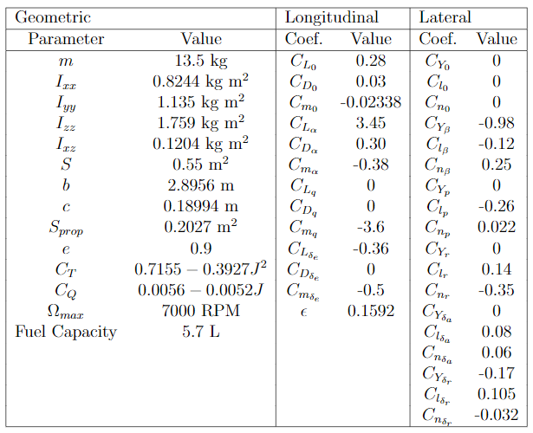

**Range and Endurance:**

**Range:**

The range of an aircraft is technically defined as the total distance measured with respect to the ground traversed by the aircraft on one full tank of fuel. It is used to estimate engine performance in terms of fuel consumption. The maximum total range is the maximum distance an aircraft can fly between takeoff and landing, as limited by fuel capacity in powered aircraft, or cross-country speed and environmental conditions in unpowered aircraft. In this project, the maximum range of the given aircraft is calculated with respect to the propeller data obtained from the UIUC database for the given propeller (APC 16X8).

In order to calculate the range of the aircraft with respect to the different powertrain systems, the following specifications are adopted:  
1. **Specific Fuel Consumption (SFC) (for propeller)**  
Specific fuel consumption is one of the important metrics in determining the performance of a propeller-driven aircraft. SFC is defined as the weight of the fuel consumed by the reciprocating engine per unit power per unit time.  
2. **Thrust specific fuel consumption (TSFC) (for jet engine)**  
The thrust specific fuel consumption of a jet engine is defined as the fuel efficiency of an engine design with respect to thrust output. TSFC is the mass of fuel burned by an engine in one hour divided by the thrust that the engine produces.

The maximum range for the APC 16X8 propeller is calculated using the given formula:

NOTE: To cover the longest distance, common sense says that we must use the minimum fuel consumption per unit distance (e.g., km or mile).

**Endurance:**

The endurance of an aircraft is defined as the total time that an aircraft stays in the air on a tank of fuel. Like the range characteristics, to achieve maximum endurance, it is advised to use the minimum thrust per unit time.  
For a steady level flight, the lift is equal to weight and the thrust is equal to the drag (L = W, T = D).

To calculate the maximum endurance for a propeller-driven aircraft, the following parameters are required:

1. Maximum weight loss (Wf = W0 – W1)
2. Maximum Cl3/2/Cd

The maximum endurance for a propeller-driven aircraft is calculated using the given formula:

Based on the above-mentioned procedures, the results of the multi-rotor drone (quadcopter) are as follows:

Max. Range = 390.04 kms

Max. Endurance = 5.88 hours

**MULTI-ROTOR DRONE DEVELOPMENT:**

**Range and Endurance:**

For a multirotor, range can be estimated by how far it can be controlled by the controller before losing its connection. The range of a multirotor is dependent on certain factors like weight, motor power, weather conditions, etc. Based on the application requirement, they can be customized for longer ranges and better performances. In this project, the forward flight momentum theory was used to estimate the range and endurance of the aircraft for a given set of forward speeds. A velocity range of 0-20 m/s was chosen to perform this calculation and the estimated values of range, endurance, and forward speeds of the multi-rotor drone were calculated using the following steps as follows:

**Forward Flight Momentum Theory:**

The forward flight expression can be written as:

v = T/2ρA√V 2cos2αD + (v + V sinαD)2 ---- (1)

At a given forward speed, V we can then solve for αD, v, T, Pind, Ptot as follows:

1. Calculate the quadrotor drag D = 1/2ρSCDV 2 at αD=0  
   (Assume αD does not affect the drag, otherwise need to iterate to find solution
2. Solve αD = tan-1 (D/W)
3. Square both sides of Eqn 1 replace T2 by W2 + D2 and re-arrange to get,  
   v4 + (2V sin αD) v3 + V 2v2 −(W2 + D2)/(2ρA)2 = 0
4. Positive real root of equation gives v, then  
   Pind = Tv

Ptot = T (v + V sin αD)

1. Notice that this total power does not include profile drag, swirl, or additional  
   losses due to non-uniform induced velocity.
2. Solve for a range of speeds and plot results versus V

The maximum range of the quadcopter is calculated using the formula:

Max. Range = (Eb * m_e * esc_e) / (Minimum Total Power/Velocity)

Eb = Energy of the battery

M_e = Motor efficiency

Esc_e = ESC efficiency

The maximum endurance of the quadcopter is calculated using the formula:

Max. Endurance = (Eb * m_e * esc_e) / (Minimum Total Power)

Eb = Energy of the battery

M_e = Motor efficiency

Esc_e = ESC efficiency

Based on the above-mentioned procedures, the results of the multi-rotor drone (quadcopter) are as follows:

Max. Range = 34 kms

Max. Endurance = 68.1 minutes

Forward Speed for range = 9.5 m/s

Forward Speed for endurance = 7 m/s

**Development of Quadrotor Dynamics Model:**

The development of dynamics model of quadrotor was done by using the following state space matrices given for each control channel.

Roll:

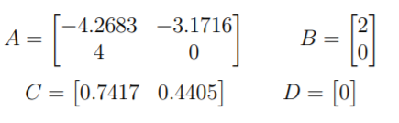

Pitch:

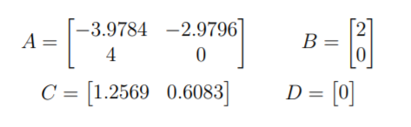

Yaw:

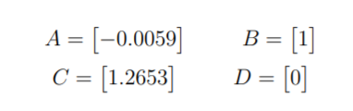

Height:

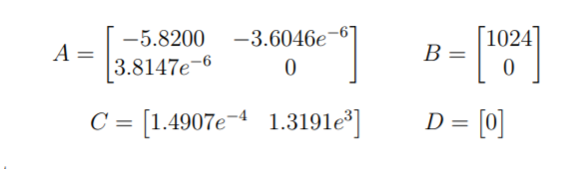

Pitch to u:

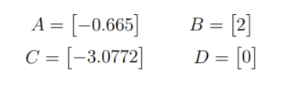

Roll to v:

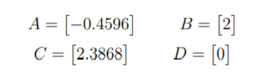

The output from position controller was fed into the dynamics model. The dynamics model consists of each control channel mentioned above put in a separate state-space block in Simulink. For roll control the input was the desired roll angle and the output from the state-space block was the actual roll angle. This actual roll angle was then fed into the roll to v control channel as input, to get the actual velocity v about y-axis.

For pitch control the input was desired pitch angle and the output was the actual pitch angle. This actual pitch angle was then fed into the pitch to u control channel which gives the actual velocity about x-axis.

Yaw control channel used desired yaw rate, also called as desired heading rate, for input while the output of this control channel is actual yaw angle. The last control channel used for the dynamic model of this quadrotor is altitude control, for this the input was desired vertical velocity w while the output was orientation along z- axis, which is also called altitude.

The Simulink design of Dynamic Model is shown in the figure below:

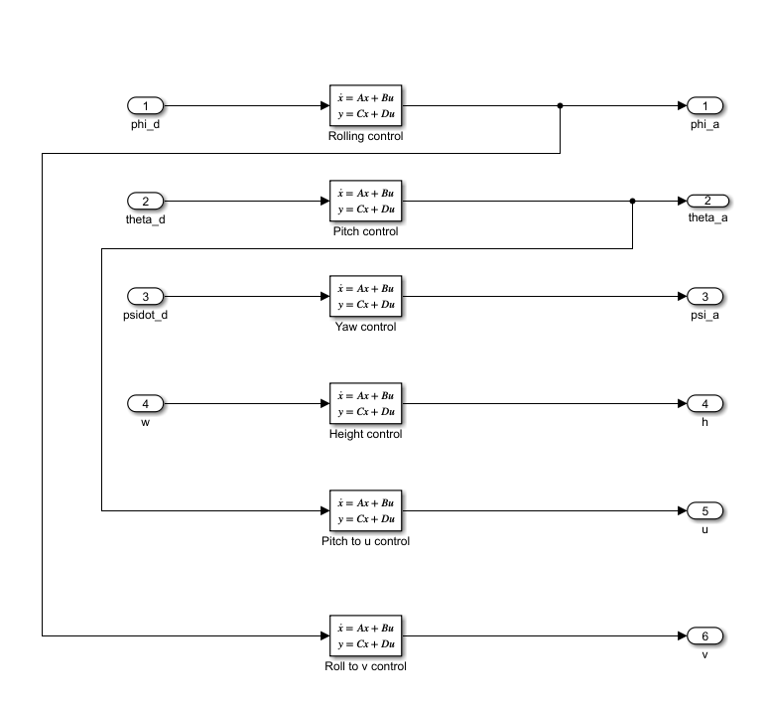

**Development of Position/Orientation control system:**

Position/Orientation Control System contains two types of state input, one is the target x, y, and z coordinate input and the other is actual x, y and z coordinates of the quadrotor. A reference yaw command is also given into the position controller to ensure that the quadrotor maintains the commanded yaw while operating for the target position.

The target x coordinate is given into a summation block while the actual x orientation of the quadrotor is given to the summation block as feedback. This command is fed into the PD controller, which gives corresponding derivative ẋ (i.e., speed along x axis). This derived velocity u is given to the summation block whereas the actual velocity ua is given as feedback in the same block. A PD controller is used again which finally gives the derivative x_dot_dot .

Similarly, target y position and actual y position of the quadrotor is also given into the summation block and then into the PD controller. The output from this PD controller is further given into a summation block where the actual velocity v is given as feedback. This output is then given into the PD controller to get acceleration along y-axis.

Actual heading angle psi, along with x_dot_dot and y_dot_dot is used to calculate the desired pitch angle and desired roll angle. The following equations [reference no?] are used for this:

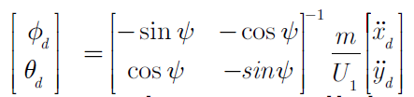

Since the derivation of these equations in (reference no) uses small angle approximation, we must ensure that the desired angles theta_d and phi_d are within the limit of –20° and 20°. Therefore, a saturation block is placed at the output of MATLAB function block.

We also need the desired vertical velocity w and the desired heading rate psi_dot to be given into the dynamics model of the quadrotor. For this, desired z coordinate and actual z coordinate are given into a summation block and PD controller is used to obtain the desired w velocity. Similarly, actual yaw angle and desired yaw angle along with PD controller are used to obtain heading rate psi_dot.

**Development of Position Estimation:**

For estimating the position of the quadrotor, the output states from the dynamic model i.e., psi, psi, theta, h, u and v, are used. The dynamic model provides information about the actual value of states of the quadrotor. To acquire data regarding the actual x and y coordinated of the quadrotor we integrate the u and v velocities, respectively. The Simulink model of position estimation subsystem is shown in Figure ( ) .

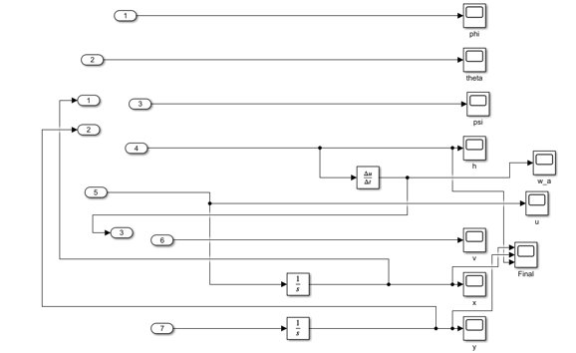

**Development of linear simulation model:**

For the development of the linear simulation model, a reference subsystem was created which was used for giving the desired coordinate information to the position controller. The desired pitch and roll angles theta_d and phi_d along with the heading rate psi_dot and desired vertical velocity wd goes into a summation block followed by a PID controller. To this summation block feedback is given of actual orientation of the respective states.

Further, these values are given into the dynamics model subsystem which is also explained in the previous section. The actual values obtained from the dynamic model are used in the position estimation subsystem to get information about Euler angles, position, and velocities of the quadrotor.

The reference position subsystem developed in for this project is an If-Else condition block which is used with Action block to activate a particular command for an If-Else condition. The reference command subsystem is shown in the figure ( ).

[NEED A CLEAR PICTURE OF REFERENCE POSITION SUBSYSTEM]

The complete linear simulation system that was developed in Simulink is shown in the figure ( )

PID Tuning methods used for this project were Inbuilt PID tuners provided by Simulink. For tuning PD controllers, the following steps were taken:

1. Proportional gain Kp was increased until steady oscillations were obtained.
2. Derivate gain Kd was increased until the oscillations were critically damped.

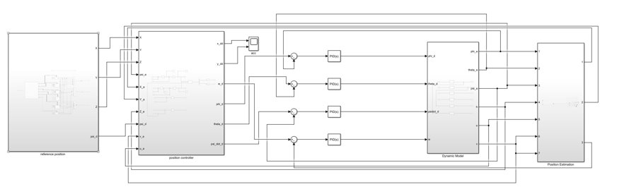[NEED A GOOD QUALITY PICTURE OF THE ENTIRE MULTIROTOR CONTROL SYSTEM]

Total simulation time was taken to be 1500 seconds for the following four maneuvers:

1. Take off and hover at 2 meters above origin
2. Fly to the first target (x = 5 m, y = 6 m, h = 4 m) and hover
3. Fly to the second target (x = -5 m, y = -6 m, h = 4 m) and hover
4. Return to 2 meters above origin and land.

**Result:**

The quadcopter was successfully able to complete all the given maneuvers for this project. The simulation result, which shows the trajectory of x, y and z coordinates of the quadcopter for 1500 seconds is shown in figure ( ) .

In the figure the quadcopter is initially at x=0, y=0 and z=0 position, in the first 300 seconds it takes off and hover at x=0 y=0 and z=2 m. Next, the quadcopter reaches to x=5, y=6 and z=4.For the third maneuver it goes from its current position to the target position, x=-5, y=-6 and z=4 and then for the last maneuver is goes from current position to target position of x=0, y=0 and z= 2 and then back to the origin.

**[ADD A PICTURE OF FINAL RESULTS]**

**CONCLUSIONS AND LESSONS LEARNED:**

The various lessons learned during the implementation of the fixed-wing and multi-rotor UAS configurations are listed below as follows:

* The theoretical values obtained using various theories like the Momentum Theory or Thin-Airfoil theory will vary largely from the obtained values of a flying system because of the assumptions and inconsistencies in data.
* Implementation of non-linear dynamics will resonate more with real-time data than with the implementation of a linearized system. Linearization can be done for learning about the properties of the system and simulation, but not for real-time flight dynamics.
* The obtained values of range and endurance in the fixed-wing and multirotor aircraft are large and unrealistic, mainly because of the inconsistencies in the data.
* About PID control:
* About altitude hold control/position control:
* About simulations and maneuvers:

**Bibliography:**

1. [**https://www.lycoming.com/engines/el-005**](https://www.lycoming.com/engines/el-005)
2. [**https://m-selig.ae.illinois.edu/props/volume-3/propDB-volume-3.html**](https://m-selig.ae.illinois.edu/props/volume-3/propDB-volume-3.html)
3. **Heba Elkholy, American University in Cairo, Egypt Maki; K. HabibAmerican University in Cairo, Egypt - Chapter 2 – Dynamic Modelling and Control Techniques for a quadrotor**
4. [**https://www.textronsystems.com/products/aerosonde**](https://www.textronsystems.com/products/aerosonde)
5. [**https://ai.stanford.edu/~gabeh/papers/Quadrotor_Dynamics_GNC07.pdf**](https://ai.stanford.edu/~gabeh/papers/Quadrotor_Dynamics_GNC07.pdf)
6. [**https://nptel.ac.in/content/storage2/courses/101104007/Module2/Lec8.pdf**](https://nptel.ac.in/content/storage2/courses/101104007/Module2/Lec8.pdf)